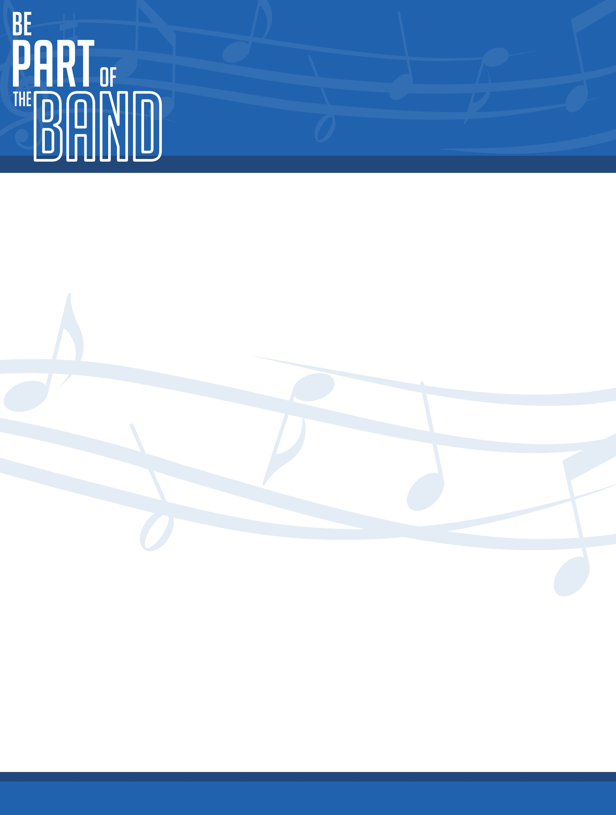

De Smet High School Band Handbook

Table of Contents

- Mission Statement
- Goals
- Band Director
- Director Contact Information
- Music Department Schedule
- Pep Band Schedule
- Mrs. Vockrodt’s Schedule
- Grading
- Other Opportunities
- Rehearsal Expectations
- Challenging
- Concert Etiquette
- Concert Dress Code
- Band Trip Guidelines
- Instrument “Step-up” List

Forms to Sign

- Student/Parent Contract
- Remind

Mission Statement

Mrs. Vockrodt’s Mission Statement

I am committed to the success of my students through providing a wholesome education and worthwhile life skills. I will mentor and grow students into musicians through efficient and effective hands-on learning while creating music and having fun.

De Smet Band Program Mission Statement

The De Smet Band Program serves to provide a high quality musical experience for all of its members while fostering in them a lifelong love for music. By pursuing excellence at all times, our members will have the opportunity to work in harmony with each other to develop skills that will benefit them in all of their musical endeavors. Students will learn discipline, commitment, perseverance, and the satisfaction of achieving success by being the absolute best they can be. Life lessons such as these will enable students to be successful in every area of their lives.

Goals

- To provide a comprehensive knowledge of music through the performance, creation, and promotion of music.
- To provide an environment that promotes and encourages life-long learning and personal as well as professional growth.
- To create an environment that provides all students with a sense of community and loyalty to an organization bigger than themselves.
- To provide an opportunity for students to develop as disciplined, organized, and mature adults.
- To allow students to express themselves in a different, creative manner through the means of music.

Band Director

Director: Mrs. Kayla Vockrodt graduated in 2013 from Deubrook High School in White, South Dakota. In 2017, she received her Bachelor of Music Education from Northern State University in Aberdeen, South Dakota. She has a degree to teach both

K-12 Band and Choir. Mrs. Vockrodt was involved in many ensembles over the years including the National FFA Band, South Dakota All-State Band, Intercollegiate Band, Marching Wolves, including marching for the 75th anniversary of Pearl Harbor in Hawaii, Jazz Band, Orchestra, Clarinet Choir, Concert Band, Concert Choir, and was first chair clarinet for the NSU Symphonic Band. She enjoys teaching lessons and is excited to begin her career in teaching music.

Director Contact Information

Miss Kayla Vockrodt: 605-854-3674 (School Phone #)
Kayla.Vockrodt@k12.sd.us (School E-mail)

Website: http://desmetband.weebly.com/

De Smet Music Department
Important Dates 2018-2019

September
Sept 5 Region III Music Meeting 4:30 P.M. Watertown
Sept 19 Registration deadline for All-State Orchestra Auditions

October
Oct 2 HS Pops Concert
Oct 5 All State Chorus Registration due
Oct 9 All-State Orchestra Auditions Huron
Oct 11 Choral Leadership Workshop (Mixed Octet) Brookings
Oct 18 Mixed Octet Workshop (AM) Arlington
Oct 25-28 All-State Chorus and Orchestra Rapid City

November
Nov 7 Instrument Day at Northern
Nov 9 Veteran’s Day program 10:30 A.M.
Nov 29 MS/HS Fall Concert

December
Dec 11 Registration deadline for All-State Band Auditions
Dec 13 LIW Christmas Concert
Dec 14 Audition deadline for Middle School All-State Band

January
Jan 25 All-State Band Auditions Watertown

February
Feb 7-9 SD Music In-service Conference Brookings
Feb 26 Afternoon of Arts De Smet
Feb 27 HS Region III Solo/Ensemble Contest Watertown

March
Mar 1-2 Middle School All-State Band Huron
Mar 5 East Central Middle School Honor Band Brookings
Mar 8 Audition deadline for All-State Jazz Band
Mar 12 USD Jazz Festival (Show Choir) Vermillion
Mar 21-23 HS All-State Band Aberdeen

April
Apr 4 4-8 Spring Concert
Apr 30 K-3 Spring Concert
Apr 25-26 All-State Jazz Band Aberdeen

May
May 2 HS Spring Concert (golf DS 1:00)
May 11 LIW/MS Band Contest De Smet
May 18 Graduation
Pep Band Schedule 2018-2019

Thursday, Sept 6 | Coronation | College Boy | Call time 6:45 pm
Friday, Sept. 7 | FB vs. Estelline/Hendricks | On Wisconsin | Call time 6:30 pm
Tuesday, Sept. 11 | VB vs. Sioux Valley | On Wisconsin | Call time 7:00 pm
Friday, Sept. 14 | FB vs. DRSM | On Wisconsin | Call time 6:30 pm
Friday Sept. 28 | FB vs. Elkton/Lake Benton | Notre Dame Victory March | Call time 6:30 pm
Thursday, Oct. 4 | VB vs. Deubrook | Washington & Lee Swing | Call time 7:00 pm
Tuesday, Oct. 9 | VB vs. Hamlin | Go Northwestern | Call time 7:00 pm
Monday, Oct. 22 | VB vs. Arlington | Arlington Fight Song | Call time 7:00 pm
Thurs, Dec. 6 | Wrestling vs. Huron, Watertown, | Illinois Loyalty, | Call time 4:30 pm
 | Warner/Northwestern | Original,
Tuesday, Dec. 11 | BBB vs. Clark/Willow Lake | Wave The Flag | Call time 7:00 pm
Tuesday, Dec. 18 | GBB vs. Clark/Willow Lake | Wave The Flag | Call time 7:00 pm
Tuesday, Jan. 8 | BBB vs. Howard | College Boy | Call time 7:00 pm
Thursday, Jan. 10 | GBB vs. Colman-Egan | The Victors | Call time 7:00 pm
Thursday, Jan. 17 | GBB vs. Castlewood | Minnesota Rouser | Call time 7:00 pm
Thursday, Jan. 31 | BBB vs. ORR | Wave The Flag | Call time 7:00 pm

As a member of the High School Band you are REQUIRED to be at the following events as part of your grade. Please see to it that you make arrangements to attend every event, according to the Band Handbook.

You guys are GREAT musicians! Let’s show our Bulldog Spirit
and have some FUN doing what we do best

It is likely that we will be asked to play at some tournaments and other events on rather short notice. If that is the case, I will notify you as soon as possible so you can make arrangements.

Possible Games to Play:
October 18th | Football Playoffs |  | February 18th | Girls BB Regions
October 25th | Football Playoffs |  | February 19th | Girls BB Regions
November 2nd | Football Playoffs |  | February 21st | Girls BB Regions
October 29th | Volleyball Regions |  | February 25th | Boys BB Regions
October 30st | Volleyball Regions |  | February 26th | Boys BB Regions
November 1st | Volleyball Regions |  | March 1st | Boys BB Regions

Mrs. Vockrodt’s Weekly Schedule
 |  | Monday | Tuesday | Wednesday | Thursday | Friday
 | 8:00-8:20 | LIW Lessons | LIW Lessons | LIW Lessons | LIW Lessons | LIW Lessons
1 | 8:17-9:07 | LIW Lessons | LIW Lessons | LIW Lessons | LIW Lessons | LIW Lessons
2 | 9:09-9:59 | 8th Music | 7th Music | 8th Music | 7th Music | 8th Music
3 | 10:01-10:51 | LIW Lesson | 6th Music | LIW Lesson | 6th Music | LIW Lesson
4 | 10:53-11:43 | 5th Band at HS  11:15-11:45 | Plan | 5th Band at HS  11:15-11:45 | Plan | 5th Band at HS  11:15-11:45
 | 11:43-12:09 | Lunch | Lunch | Lunch | Lunch | Lunch
5 | 12:07-12:57 | HS Study Hall | HS Study Hall | HS Study Hall | HS Study Hall | HS Study Hall
6 | 12:59-1:49 | Lessons/Plan | Lessons/Plan | Lessons/Plan | Lessons/Plan | Lessons/Plan
7 | 1:51-2:41 | HS Band | HS Band | HS Band | HS Band | HS Band
8 | 2:43-3:33 | MS Band | MS Band | MS Band | MS Band | MS Band
 | 3:33-4:00 | Lessons at HS | Lessons at HS | Lessons at HS | Lessons at HS | Lessons at HS

Quarters 1 & 3
 |  | Monday | Tuesday | Wednesday | Thursday | Friday
 | 8:00-8:20 | LIW Lessons | LIW Lessons | LIW Lessons | LIW Lessons | LIW Lessons
1 | 8:17-9:07 | LIW Lessons | LIW Lessons | LIW Lessons | LIW Lessons | LIW Lessons
2 | 9:09-9:59 | 7th Music | 8th Music | 7th Music | 8th Music | 7th Music
3 | 10:01-10:51 | 6th Music | LIW Lesson | 6th Music | LIW Lesson | 6th Music
4 | 10:53-11:43 | 5th Band at HS  11:15-11:45 | Plan | 5th Band at HS  11:15-11:45 | Plan | 5th Band at HS  11:15-11:45
 | 11:43-12:09 | Lunch | Lunch | Lunch | Lunch | Lunch
5 | 12:07-12:57 | HS Study Hall | HS Study Hall | HS Study Hall | HS Study Hall | HS Study Hall
6 | 12:59-1:49 | Lessons/Plan | Lessons/Plan | Lessons/Plan | Lessons/Plan | Lessons/Plan
7 | 1:51-2:41 | HS Band | HS Band | HS Band | HS Band | HS Band
8 | 2:43-3:33 | MS Band | MS Band | MS Band | MS Band | MS Band
 | 3:33-4:00 | Lessons at HS | Lessons at HS | Lessons at HS | Lessons at HS | Lessons at HS

Quarters 2 & 4

- 8th Grade Music: MWF 1st and 3rd Quarters T-Th 2nd and 4th Quarters
- 7th Grade Music: T-Th 1st and 3rd Quarters MWF 2nd and 4th Quarters
- 6th Grade Music: T-Th 1st and 3rd Quarters MWF 2nd and 4th Quarters

Grading

Daily Points
Students will automatically receive 10 points each day for coming to class prepared. Participation points are kept by following expectations in class. S – Sit Tall, T – Track the Speaker, A – be Appropriate/Attitude, and R – Respect. Students will lose points if they do not follow these rules. If a student has an unexcused absence, they will receive a 0 for the day. Excused absences include: school activities, sickness, family emergencies such as a death in the family, etc. Refer to school handbook if needed.

Concerts
Students are required to attend each concert for a grade. Parents are highly encouraged to come. Concerts are required as a final test in band each semester. If a student is unable to come to a concert, the parents and student must talk to me ahead of time. The student will have to make up the concert by watching the concert online, answering questions about the concert, and playing their music for me. If the concert is not made up, the student will receive a zero for work completed on the concert and will be in ICU until it is complete.

Pep Band
Students that are in High School Band are required to come to all scheduled pep band games. If you are involved in the sport that we are playing for, you are excused from pep band. JV players can join us as soon as their duty to their sport is finished. You will receive 10 points for each game attended. Unexcused absences will result in a zero for that game. If you have an excused absence, please let me know before the game. If you are late for pep band, points will be deducted for how much time you are missing.

Extra Credit
- At the end of each concert, students can bring me their music and show me the notes that they have made in their music. For every 5 markings, I will award 1 point.
- For every 10 minutes a student practices at home, I will give them 1 point of extra credit. This must be a recorded session on the student’s computer and signed by a parent on a practice record.

Other
There may be other areas of grading depending on what we are learning each quarter. Other areas of grading may include Class Trips, Projects, Signing the Handbook Contract, and others.

Other Opportunities

Star Spangled Banner

Students in grades 9-12 can audition to represent De Smet High School at South Dakota State sporting events. Please talk to Mrs. Vockrodt if you are interested.

All-State Orchestra
Students in grades 9-12 can audition to represent De Smet High School at the SD All State Orchestra. Auditions are in October. See me for the prepared etude, scales, audition packet, and to sign up for a few lessons with me.

All-State Band
Students in grades 9-12 can audition to represent De Smet High School at the SD All State Band. Auditions are in January. See me for the prepared etude, scales, audition packet, and to sign up for a few lessons with me.

All-State Jazz Band
Students in grades 9-12 can audition to represent De Smet High School at the SD All State Jazz Band. Recorded auditions are due in January. See me for an etude, scales, and practicing improvisation in your lessons with me.

Middle School All-State Band
Students in grades 6-8 can audition to represent De Smet Junior High School at the SDMSASB. Recorded auditions are due in December. See me for audition music, more information, and to sign up for a few lessons with me.

Middle School East Central Honor Band
Select students in grades 6-8 can be nominated to represent De Smet High School at the East Central Honor Band in Brookings on. Let me know if you are interested.

Rehearsal Expectations

Before class, you will have roughly 3 minutes after the bell rings until I start class. After about 3 minutes, I will start class and you must be sitting in your chair with your instrument in your hand. If you are not ready for class, you will lose points accordingly:
- Showing up on time.
- Sitting in your assigned seat with your instrument.
- Gum is not allowed.
- Please drink water! No other liquids or food.
- Have a pencil at all times.
- Sit in your assigned seat.
- Talk only if you have a question.
- Listen to me (your teacher!)
- No cell phones during class.
Challenging

If you would like to challenge the person ahead of you in band, you must prepare a short etude or part in the music we are working on and two scales. You have two weeks to prepare your challenge. Playing ability, leadership skills, and attitude in class will all be assessed in the decision. If you are challenged and you do not want to participate, you will have to give up your chair in forfeit.

Concert Etiquette
for parents & students

- Don’t talk during performances! Your children and peers worked very hard to put on a concert to entertain you. Let them show you how great they are!
- Please turn off your cell phone. Not only could it go off during the performance and distract your fellow audience members, but it follows the same idea as talking. It takes away from you listening to the hard work of the students!
- Take photos! Record the performance! I love that you want to support your students and peers in the De Smet High School Band Program, but please do not get in the way of other audience members. Stay in your seat and turn off your flash on your camera.
- Do not leave when you or your child’s portion of the concert is over. Each student at De Smet has worked very hard on their music especially for you!
- Applaud between pieces! If there is more than one movement to the piece, wait until the very end to show your appreciation of the music.
- If you need to leave during the performance, do not leave while a piece is being performed. Leave and return to the concert hall between pieces. Don’t distract your fellow audience members from the performance.

Concert Dress Code

If we have a concert, are going to contest, auditions, etc., students will use the following guidelines below for concert dress code. Ask Mrs. Vockrodt if you are wondering about the dress code BEFORE the event. If you are questioning what you are wearing, you probably shouldn’t wear it.

Ladies
- Modest clothing
- Leggings worn as pants is not acceptable
- Dresses must be no shorter than right above the knee

Men
- Khakis or dress pants
- Polo or dress shirt
- Any kind of dress shoes
  - NO tennis shoes
- You may wear a tie

Band Trip Guidelines

All Band Trip Rules
- All school rules apply on trips.
- Students must show respect to chaperones at all times.
- All bus travel procedures must be followed. Always obey those in charge. Stay in your seats. Throw away your trash.
- On overnight trips on the bus, girls will sit with girls and guys will sit with guys.
- Display proper behavior while traveling as a group at all times. Please refrain from causing disturbances or activities that are meant to attract attention to you as an individual. Set a good example for others.
- Report any and all illness to a chaperone immediately.
- Do not provide medicine of any sort to yourself or any member of your group.
- All medications must be given to a designated chaperone in a prescription bottle with a signed note from your parent/guardian.
- Always travel in groups of 3 or more.
- Let a chaperone know if you need to go somewhere at all times.
- All students are responsible for the same rules that apply during the school day. Any actions requiring administrative support will be handled in that manner. If you have any questions regarding these, rules, please refer to the student conduct section in your school handbook.
- Absolutely NO drugs or alcohol.
- Any rules in the school handbook must also be followed.

Hotel Rules
- If we are in a hotel, show respect to the other guests. Be quiet.
- All hotel room doors must be opened promptly at the request of a chaperone or the director – and only opened to a chaperone or the director after lights out.
- No guys in girls rooms and vice versa.
- After lights out and room check you must stay in your room.

Disciplinary Actions
- When infractions of the rules occur any of the following actions may be taken. Each situation is different and the band director will keep this in mind when giving consequences.
- I have a one strike policy on trips. Students will receive only one warning before further disciplinary action is taken.
- The student(s) involved will be constantly chaperoned for the remainder of the trip. The student will then stay with an adult at all times including at night.
- The student(s) involved will be sent home with a chaperone with all costs payable by the parents and/or students involved.
- Upon returning to school, appropriate referral measure will be carried out by the building administrators.

Instrument Step-Up List

Flute (open hole)
1) Pearl 665 RB Coda Series (Solid Silver Headjoint, with B foot)
2) Pearl 765 RB Coda Series (Solid Silver Headjoint, with B foot)

Clarinet (all Grenadilla wood)
1) Buffet R­13 (either Grenadilla wood or Greenline)
2) Buffet E­11
3) Leblanc Noblet 40 or 45
4) Yamaha YCL­450

Clarinet Step­Up Mouthpiece Kit:
1) Mouthpiece: Vandoren 5RV Lyre; Rico Reserve (see me about which kind!)
2) Ligature: D. Bonade inverted 2250 Nickel; Luyben plastic ligature; or Vandoren “Optimum” Silver ligature; or Rovner Dark Bb (leather)
3) Vandoren Reeds (2.5 or 3)
4) "Thumb Ease" (thick thumb pad)
5) Mouthpiece patch (rubber patch that goes on top of mouthpiece)
6) Reed Case: Protec, Vandoren, Selmer

Alto Saxophone
1) Selmer La Voix II or Super Action 80 Series II
2) Yamaha YAS­62ll

Tenor Saxophone
1) Selmer Super Action 80 Series II
2) Cannonball wide­bell
3) Yamaha YTS­52
Lacquer: Silver (brighter sound), Black (mellow), Gold (usual)

Sax Step­Up Mouthpiece Kit:
1) Mouthpiece: Selmer C Star, Meyer G5 (jazz), Metal Jazz Selmer C Star
2) Ligature: D. Bonade inverted
3) Vandoren Reeds (2.5 or 3)
4) Mouthpiece patch (rubber patch that goes on top of mouthpiece)
5) Reed Case: Protec, Vandoren, Selmer

French Horn
1) Yamaha YHR­668NDII Professional Double French Horn
2) Conn 8­D Connstellation Series Double French Horn, Nickel Silver Fixed Bell
3) Holton
Mouthpieces: Laskey 75G, Moosewood B12

Trumpet
1) Yamaha YTR­8335RGS Xeno
2) Selmer Bach Stradivarius 180
3) Blessing BTR-1469
4) Bach TR200 or 180S37
Mouthpieces: Bach 7C, 3E, 1B, 17C,
Curry 7C, 3C, 00S, Jet Tone 10

Trombone

(with F trigger attachment)
1) Selmer Bach 36B Med­Lg bore .525
2) Selmer Bach 42B .547 bore
3) Conn 88H .547 bore
Mouthpieces: Bach 3G, 5G, 5GS, 7C, 6 ½ AL, Yamaha 51C4

Euphonium (Large Bore)
1) Yamaha YEP­321S
2) Mack Brass
Mouthpieces: Shilke 51D

Tuba
1) Holton Collegiate BB460
2) St. Petersburg 202
3) Conn 5J
Mouthpieces: Bach 18, 12, 7, 24AW,
Conn Helleberg Standard of Deep

Student/Parent Band Contract
SIGN AND RETURN BY September 4, 2018

- I have discussed and reviewed all the information in the handbook with my child, and I understand its contents and my responsibility as to these policies and conditions.
- As a student, I understand that I am an important part of the ‘team’ called band, and my participation and effort, whether positive or negative, greatly impact the overall outcome. A team cannot function without each player doing their part.
- As a parent, I support my student’s decision to participate in band at De Smet Junior High & High School.
- We understand that band is a unique experience filled with rewards for those who strive to meet goals. We also understand the idea of cooperative goals and the responsibility of each individual in meeting those goals in a timely fashion.
- We agree to do our part to help the director and the administration of De Smet High School to meet the musical demands of the De Smet High School Band Program.
- My child has my permission to attend district, out-of-district trips and school-sponsored extra-curricular and co-curricular activities.
- I understand that De Smet School District will not be liable for injuries and medical cost for students. My signature also serves as permission for my child to obtain medical treatment on a school-sponsored trip.
I have read the policies and participant expectations, and agree to abide by them by signing this document.

Student Signature ________________________________ Date ___________

Parent Signature _________________________________ Date ___________

Remind

Please sign up you and your student(s) at www.remind.com, by downloading the Remind App, or by texting 81010 and join using these codes:

Band - @dsband MS Band - @dsmsband 5th grade Band - @ds5band
MS Music - @678music

I will use Remind to send out reminders of concerts/pep band, stay connected with students/parents, and to keep everyone informed. STUDENTS ARE REQUIRED to sign up for Remind. If they do not have a cell phone, they can sign up with their school email.

Parent signed up for Remind Yes ______ No ______

Student signed up for Remind Yes ______ No ______

